Step 0 Intake + Interview Filing Status, Dependency
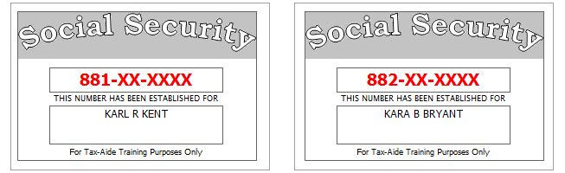
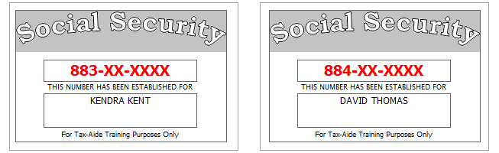
Karl and Kara have been married for several years and are currently full-time residents of Pluckemin, New Jersey. They want to file both a federal and a state return.
Their daughter, Kendra, is a full-time student classified as a junior at her college.
No one else can claim Kendra or Dave as a dependent.
Carmen Bryant is Kara’s older sister who is totally and permanently disabled (Type of Disability: Unknown). Carmen lived with the Kents all year and was fully supported by them. No one else can claim her as a dependent and she earned no income.
Karl and Kara provided 100% of the support for both Kendra and Dave.
Reference: 4012 Tab A, B, C
Tool: IRS Interactive Tax Assistant (link on Preparer page)
Tool: AARP Resource Tool for Counselors (Laminated Flow Chart
Tool: TP4F Qualifying Child/Qualifying Relative Flowchart Tool (link on Preparer page)
Tool: Dependent Calculator (link on Preparer page)
Step 1 Basic Information
Use the Filing Status from Step 0
Use Intake Sheet and Social Security cards
Extra Interview information for New Jersey:
- All dependents have health insurance (as of the time the return is filed)
- Kendra is 21 and is a full-time student classified as a junior at her college.
- Kara would like $1 to go to the Gubernatorial Election Campaign Fund, while Karl does not wish to contribute to the Gubernatorial Fund.
Reference: 4012 K-3 to K-4
Tool: NJ Municipality Code Lookup Tool (link on Preparer page)
Tool: NJ 1040 Instructions – Municipality Code Table
Hint: For Profile, use Basic (No Profile)
Hint: Use names from SS Cards (NOT Intake Sheet)
Hint: A simple NJ return will be added after filling in the Federal Personal Information screen. Answer only the subset of the NJ Basic questions asked
Hint: Do not go to the State Section and do anything until you are done with the Federal Section and Health Insurance sections. Use the NJ Checklist to record things you will need to remember when doing the State Section later.
Hint: You do not need to remember or record the NJ PIN
Hint: Add each dependent separately
NJ: Fill in Basic Information section of NJ Checklist now

Federal Refund: 0 NJ Refund Amount: 0

Step 2 W-2
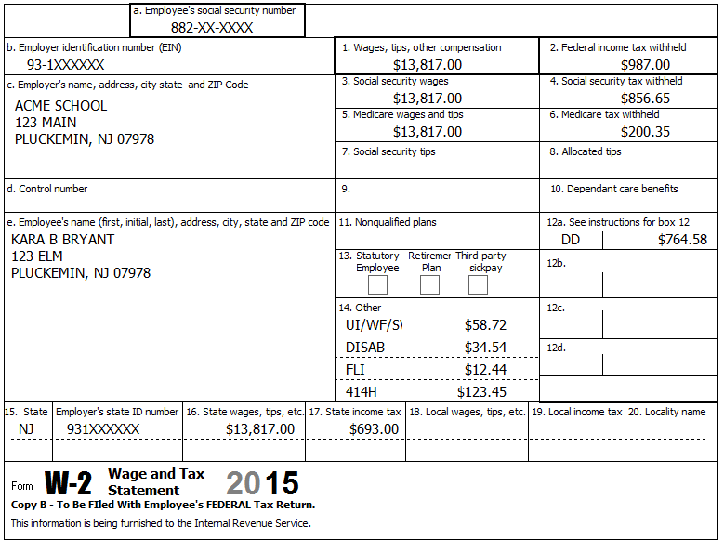
Reference: 4012 D-9 to D-10
Reference: NJ Special Handling p?
Hint: If the name and address of the employer come up after inputting the Employer Identification Number, check that the information is correct and change as necessary
xTWO Hint: There is no need (or capability) to “override” in TSO – if something needs to be changed, (e.g. Employer or Employee address, NJ boxes, etc.)
xTWO Hint: The automatic calculation for Boxes 1-6 is not the same as you might be used to in TWO – double check amounts before Continue
Hint: Box 14 NJ codes may not match dropdown exactly
Federal Refund: 8,208 NJ Refund Amount: 2,559
Step 3 W-2
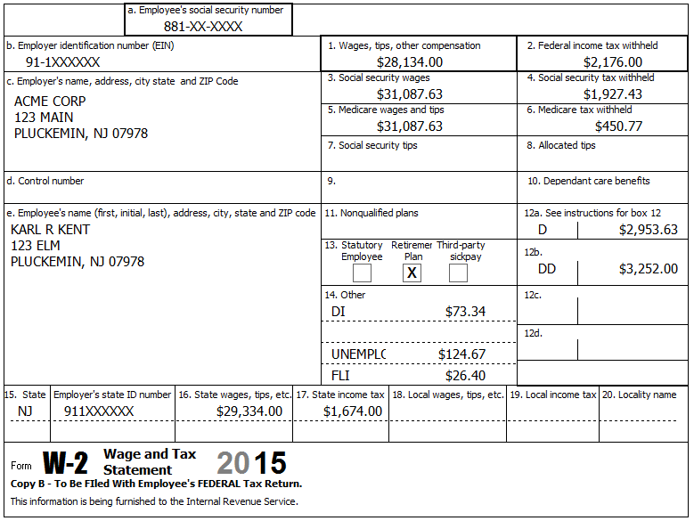
Karl’s W-2 / final pay stub had extra detail showing $1,200 for a Section 125 (pre-tax federal / after-tax NJ) Dental plan.
Reference: 4012 D-9 to D-10
Reference: NJ Special Handling p?
NJ: Record Section 125 amount on NJ Checklist now
xTWO Hint: The automatic calculation for Boxes 1-6 is not the same as you might be used to in TWO – double check amounts before Continue
Federal Refund: 5,928 NJ Refund Amount: 2,526

Step 4 Seller Financed Mortgage
Neither Karl nor Kara had an interest in or a signature or other authority over a financial account in a foreign country.
Last year’s return showed a seller-financed mortgage on Sch B.
Karl is collecting payments on a seller-financed mortgage. The purchaser is Charles Campbell (SSN 885-XX-XXXX), 123 Maple, Pluckemin, NJ 07978. This year Karl received $2,782.15 interest on that loan.
Reference: 4012 D-16
Tool: TaxPrep4Free.org Form Lookup Tool
xTWO Hint: Use the Form Lookup Tool if you’re having trouble finding where to enter Seller Financed Mortgage.
Federal Refund: 5,074 NJ Refund Amount: 2,305
Step 5 1099-INT
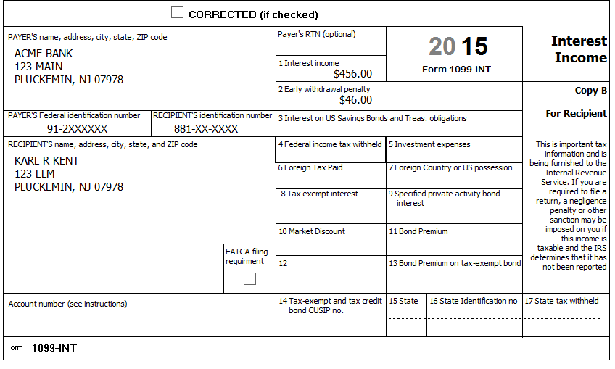
Reference: 4012 D-13
Federal Refund: 4,950 NJ Refund Amount: 2,273

Step 6 Brokerage Statement Page 1 of 3 – 1099-INT
Acme Brokerage | End of Year Tax Information Statement  Account 203040506 | Statement Date: 01-30-2016  Page 1 of 3 | 2015
123 Main Street  P.O. Box 07978-123  Pluckemin, NJ 07978  PAYER’S Federal ID No: 92-2XXXXXX | Karl R. Kent  123 Elm  Pluckemin, NJ 07978  RECIPIENT’S ID No: 881-XX-XXXX | Your Broker:  Serge Bronski  888-555-5555  sbronski@AcmeBrokerage.com

Interest Income – 1099-INT – Reported to IRS
1 | Interest Income (not included in line 3) | 123.00
2 | Early withdrawal penalty | 0.00
3 | Interest on US Savings Bonds & Treasury obligations | 2,455.00
4 | Federal Income tax withheld | 245.00
5 | Investment expenses | 0.00
6 | Foreign tax paid | 0.00
7 | Foreign country or US possession
8 | Tax-exempt interest (includes line 9) | 337.85
9 | Specified private activity bond interest (AMT) | 0.00
10 | Tax-exempt bond CUSIP numbers (see instructions)
11 | State
12 | State ID numbers
13 | State tax withheld | 0.00
 | FATCA filing requirement | NO

Interest Detail (only summary 1099-INT reported to IRS)
Date | 1 Interest Income | 2 Early withdrawal penalty | 3 Interest on US Savings Bonds | 4 Federal withholding | 8 Tax-exempt interest
MooFoo Mutual Fund
12-30-2015 | 123.00 | 0.00 | 2,455.00 | 245.00 | 0.00
New Jersey Muni Bond
12-30-2015 | 0.00 | 0.00 | 0.00 | 0.00 | 148.63
Georgia Muni Bond
12-30-2015 | 0.00 | 0.00 | 0.00 | 0.00 | 189.22
Totals: | 123.00 | 0.00 | 2,455.00 | 245.00 | 337.85

Money from U.S. Savings Bonds was used for house repairs.
Reference: 4012 D-13 to D-14
Reference: NJ Special Handling p?
Step 6a Interest Income Screen
Hint: Ignore TS Complaint that “Amount Withheld is greater than 40% of Interest Income
Federal Refund: 3,220 NJ Refund Amount: 1,755
Step 6b Tax-Exempt / Schedule B Other Interest Screen
Federal Refund: 3,220 NJ Refund Amount: 1,751

Step 7 Brokerage Statement Page 2 of 3 – 1099-DIV
Acme Brokerage | End of Year Tax Information Statement  Account 203040506 | Statement Date: 01-30-2016  Page 2 of 3 | 2015
123 Main Street  P.O. Box 07978-123  Pluckemin, NJ 07978  PAYER’S Federal ID No: 92-2XXXXXX | Karl R. Kent  123 Elm  Pluckemin, NJ 07978  RECIPIENT’S ID No: 881-XX-XXXX | Your Broker:  Serge Bronski  888-555-5555  sbronski@AcmeBrokerage.com

Dividends and Distributions – 1099-DIV – Reported to IRS
1a | Total ordinary dividends (includes line 1b) | 231.86
1b | Qualified dividends | 125.25
2a | Total capital gain distributions (includes lines 2b, 2c, 2d) | 68.75
2b | Unrecaptured Section 1250 gain | 0.00
2c | Section 1202 gain | 0.00
2d | Collectibles (28%) gain | 0.00
3 | Nondividend distributions | 2.44
4 | Federal Income tax withheld | 0.00
5 | Investment expenses | 0.00
6 | Foreign tax paid | 3.75
7 | Foreign country or US passion
8 | Cash liquidation distributions | 0.00
9 | Noncash liquidation distributions | 0.00
10 | Exempt-interest dividends (includes line 11) | 200.00
11 | Specified private activity bond interest dividends (AMT) | 0.00
12 | State
13 | State ID number
14 | State tax withheld | 0.00
 | FATCA filing requirement | NO

Dividend Detail (only summary 1099-DIV reported to IRS)
Date | 1a Ordinary dividends | 1b Qualified dividends | 2a Capital gains | 3 Nondiv. Dists. | 4 Federal w/h | 6 Foreign tax paid | 10 Exempt Interest | 11 Sp. PAB
MooFoo Mutual Fund
12-30-2015 | 231.86 | 125.25 | 68.75 | 2.44 | 0.00 | 3.75 | 0.00 | 0.00
Select US General Fund
12-30-2015 | 0.00 | 0.00 | 0.00 | 0.00 | 0.00 | 0.00 | 100.00 | 0.00
Select NJ Qualified Fund
12-30-2015 | 0.00 | 0.00 | 0.00 | 0.00 | 0.00 | 0.00 | 100.00 | 0.00
Totals: | 231.86 | 125.25 | 68.75 | 2.44 | 0.00 | 3.75 | 200.00 | 0.00

Exempt-interest dividends by Area | Select US General Fund | Select NJ Qualified Fund
US Federal, Possessions, Territories obligations | 30.0% | 20.0%
New Jersey State and Local obligations | 10.0% | 65.0%
All Other State and Local obligations | 60.0% | 15.0%

Reference: 4012 D-14 to D-15
Step 7a Enter your Dividend Income Screen
Federal Refund: 3,214 NJ Refund Amount: 1,746
Step 7b Tax-Exempt / Schedule B Other Interest Screen
Federal Refund: 3,214 NJ Refund Amount: 1,745
Step 8 Prior Year State Income Tax Refund – 1099-G, Line 2
Looking at their prior year state return, you see that they had a $437 state income tax refund. So you check their prior year federal return and determine that they itemized deductions (and used state income taxes (5a) instead of state sales taxes (5b)).
The Kents remember receiving a refund check, but don’t remember if the amount shown on their prior year NJ return is correct, so you use the NJ online refund query tool to check on their prior year state income tax refund amount. It shows an amount consistent with the refund amount on their prior year NJ return.
Their prior year federal return shows that their total itemized deductions were $13,884.
Reference: 4012 D-11
Reference: NJ Special Handling p?
Tool: NJ Form 1099-G Inquiry (Refund)
Federal Refund: 3,184 NJ Refund Amount: 1,745

Step 9 1099-MISC and Self Employment
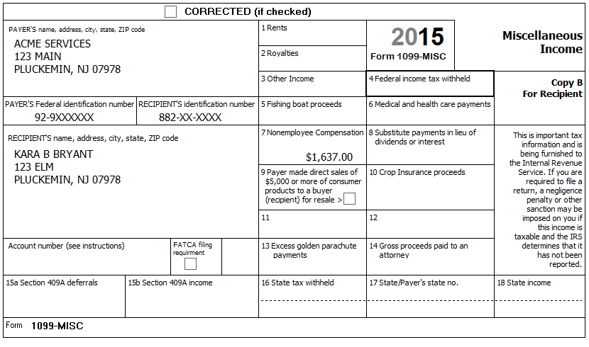
Kara has a small business, which she operates out of her home, typing medical transcripts. She received income reported on a 1099-MISC as well as $1,082 cash during the year from various other doctors for this service
She meets all scope requirements (see Pub. 4012). She has materially participated in the operation of the business for several years.
Kara used her second car (a 1966 Ford Mustang) for picking up and delivering the typing jobs. She maintained a written record of mileage, reporting 35 business miles per month and 10,000 total other miles. She bought the car and started using it for business on January 2, 2011. Kara has another car available for personal use.
Her expenses included $45.00 for paper and $67.52 for a printer cartridge.
Reference: 4012 D-29 to D-35, F-9 to F-13 (love the picture on F-12)
Tool: NAICS Search Tool (link on Preparer page)
Tool: 1040 Instructions, Sch C Business Codes table
Hint: An alternative to the built-in Business Code lookup list is to use the online NAICS Search Tool to search for the Business Code (enter keyword “typing” or “transcription” in this case)
Hint: See 4012 for suggestion of what to use for “Description of Vehicle”
Federal Refund: 2,630 NJ Refund Amount: 1,703

Step 10 Capital Loss Carryover
Looking at last year’s 1040, line 13, you see -$3,000 (a loss), so you find the Schedule D Worksheet, and you see that the Kents had no Short-term capital loss carryover, but they did have a Long-term capital loss carryover of $2,534 to this year.
Reference: 4012 D-36
Federal Refund: 2,880 NJ Refund Amount: 1,703
Step 11a Brokerage Statement Page 3 of 3 (Part 1) – 1099-B
Acme Brokerage | End of Year Tax Information Statement  Account 203040506 | Statement Date: 01-30-2016  Page 3 of 3 (Part 1) | 2015
123 Main Street  P.O. Box 07978-123  Pluckemin, NJ 07978  PAYER’S Federal ID No: 92-2XXXXXX | Karl R. Kent  123 Elm  Pluckemin, NJ 07978  RECIPIENT’S ID No: 881-XX-XXXX | Your Broker:  Serge Bronski  888-555-5555  sbronski@AcmeBrokerage.com

FORM 1099-B 2015 Proceeds from Broker and Barter Exchange Transactions
Long-term transactions for which basis is not reported to the IRS
Report on form 8949 with Box E checked and/or Schedule D, Part II
1a Description, 2 Long-term, 3 Basis not reported to IRS, 6 Net Proceeds
Quantity | 1b Date Acquired | 1c Date Sold | 1d Proceeds | 1e Cost or other Basis | 1f Code | 1g Adj | Gain / Loss(-) | 4 Federal Tax Withheld
Rio Motors Inc (RIMI)
50.000 | 09-01-2002 | 05-10-2015 | 3,462.00 | 3.181.00 |  |  | 281.00 | 0.00
100.000 | 09-01-2002 | 10-20-2015 | 7,226.00 | 6,362.00 |  |  | 864.00 | 0.00
150.000 |  |  | 10,688.00 | 9,543.00 |  | 0.00 | 1.145.00 | 0.00
Rust Corporation (RUST)
100.000 | 11-01-1999 | 09-23-2015 | 1,700.00 | 3,200.00 | W | 100.00 | -1,500.00 | 0.00
Rider Corporation (RIDE)
65.000 | ** | 10-20-2015 | 8.663.00 | ** |  |  | ** | 0.00
Totals |  |  | 21,051.00 |  |  | 100.00 |  | 0.00
** Information not available

Acme Brokerage does not have a record for the purchase of Rider stock. Karl inherited the 65 shares from his uncle who paid $6,500 for the shares on 10/15/2005. The stock was worth $7,222 on 11/29/2008, the day his uncle died.
Reference: 4012 D-36 to D-40
Hint: Use “#Shares Symbol” instead of name of brokerage for Description of property box (e.g. 100 RIMI)
Hint: The wash sale amount should be entered as a positive number
Hint: Use Alternate Option “Inherited – Long Term” for Date Acquired for inherited stock
Hint: You should have 4 Capital Gain/Loss entries in the list
Federal Refund: 2,760 NJ Refund Amount: 1,683
Step 11b Brokerage Statement Page 3 of 3 (Part 2) – 1099-B
Acme Brokerage | End of Year Tax Information Statement  Account 203040506 | Statement Date: 01-30-2016  Page 3 of 3 (Part 2) | 2015
123 Main Street  P.O. Box 07978-123  Pluckemin, NJ 07978  PAYER’S Federal ID No: 92-2XXXXXX | Karl R. Kent  123 Elm  Pluckemin, NJ 07978  RECIPIENT’S ID No: 881-XX-XXXX | Your Broker:  Serge Bronski  888-555-5555  sbronski@AcmeBrokerage.com

FORM 1099-B 2015 Proceeds from Broker and Barter Exchange Transactions
Report on form 8949 with Box A checked and/or Schedule D, Part I
1a Description, 2 Short-term, 3 Basis reported to IRS, 6 Net Proceeds
Quantity | 1b Date Acquired | 1c Date Sold | 1d Proceeds | 1e Cost or other Basis | 1f Code | 1g Adj | Gain / Loss(-) | 4 Federal Tax Withheld
Qwik Qwok (QQSV)
10.000 | 07-02-2014 | 01-15-2015 | 3,500.00 | 3,400.00 |  |  | 100.00 | 0.00
10.000 | 07-02-2014 | 03-15-2015 | 3,500.00 | 3,400.00 |  |  | 100.00 | 0.00
20.000 |  |  | 7,000.00 | 6,800.00 |  | 0.00 | 200.00 | 0.00
Slik Shok (SSVV)
30.000 | 07-02-2014 | 02-15-2015 | 3,300.00 | 3,400.00 |  |  | -100.00 | 0.00
30.000 | 07-02-2014 | 04-15-2015 | 3,400.00 | 3,400.00 |  |  | 0.00 | 0.00
60.000 |  |  | 6,700.00 | 6,800.00 |  | 0.00 | -100.00 | 0.00
Totals |  |  | 13,700.00 | 13,600.00 |  | 0.00 | 100.00 | 0.00

Reference: Special Topic: Consolidating Capital Gains (ST14-12)
Hint: Use the name of the Brokerage for “Description of Property” [Now that TWO includes “Reporting Multiple Transactions on a Single Row” as an adjustment explanation, you can disregard the suggestion in Pub 4012 to put “”M” after the name.]
Hint: Use Alternate Option “Various – Short Term” for Date Acquired for short-term consolidated transactions
Hint: Use 12/31 or latest transaction date for Date Sold for consolidated transactions
Federal Refund: 2,750 NJ Refund Amount: 1,681

Step 11c Brokerage Statement Page 3 of 3 (Part 3) – 1099-B
Acme Brokerage | End of Year Tax Information Statement  Account 203040506 | Statement Date: 01-30-2016  Page 3 of 3 (Part 3) | 2015
123 Main Street  P.O. Box 07978-123  Pluckemin, NJ 07978  PAYER’S Federal ID No: 92-2XXXXXX | Karl R. Kent  123 Elm  Pluckemin, NJ 07978  RECIPIENT’S ID No: 881-XX-XXXX | Your Broker:  Serge Bronski  888-555-5555  sbronski@AcmeBrokerage.com

FORM 1099-B 2015 Proceeds from Broker and Barter Exchange Transactions
Report on form 8949 with Box D checked and/or Schedule D, Part II
1a Description, 2 Long-term, 3 Basis reported to IRS, 6 Net Proceeds
Quantity | 1b Date Acquired | 1c Date Sold | 1d Proceeds | 1e Cost or other Basis | 1f Code | 1g Adj | Gain / Loss(-) | 4 Federal Tax Withheld
Qwik Qwok (QQSV)
10.000 | 07-02-2014 | 07-15-2015 | 3,500.00 | 3,400.00 |  |  | 100.00 | 0.00
10.000 | 07-02-2014 | 11-15-2015 | 3,500.00 | 3,400.00 |  |  | 100.00 | 0.00
20.000 |  |  | 7,000.00 | 6,800.00 |  | 0.00 | 200.00 | 0.00
Slik Shok (SSVV)
30.000 | 07-02-2014 | 08-15-2015 | 3,300.00 | 3,400.00 |  |  | -100.00 | 0.00
30.000 | 07-02-2014 | 12-15-2015 | 3,400.00 | 3,400.00 |  |  | 0.00 | 0.00
60.000 |  |  | 6,700.00 | 6,800.00 |  | 0.00 | -100.00 | 0.00
Totals |  |  | 13,700.00 | 13,600.00 |  | 0.00 | 100.00 | 0.00

Reference: Special Topic: Consolidating Capital Gains (ST14-12)
Hint: Use Alternate Option “Various – Long Term” for Date Acquired for long-term consolidated transactions
Hint: Use 12/31 or latest transaction date for Date Sold for consolidated transactions
Federal Refund: 2,740 NJ Refund Amount: 1,680
Step 12 1099-R
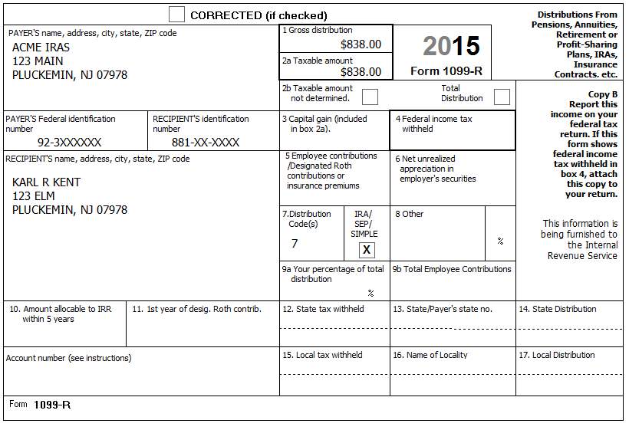
Karl met all his RMD requirement for his IRAs from the ACME IRAs account. He has no record of his original contributions.
Reference: 4012 D-17 to D-24
Federal Refund: 2,655 NJ Refund Amount: 1,680
Step 13 1099-R
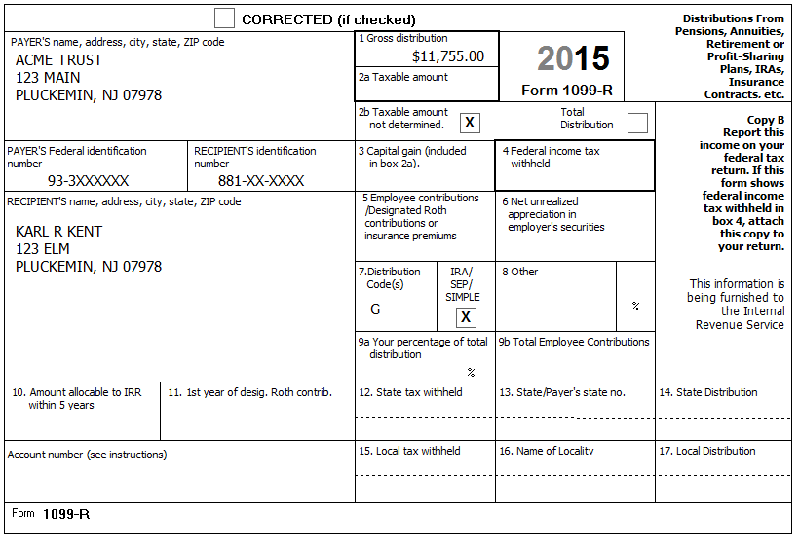
Reference: 4012 D-17 to D-24
Federal Refund: 2,655 NJ Refund Amount: 1,680
Step 14 1099-R
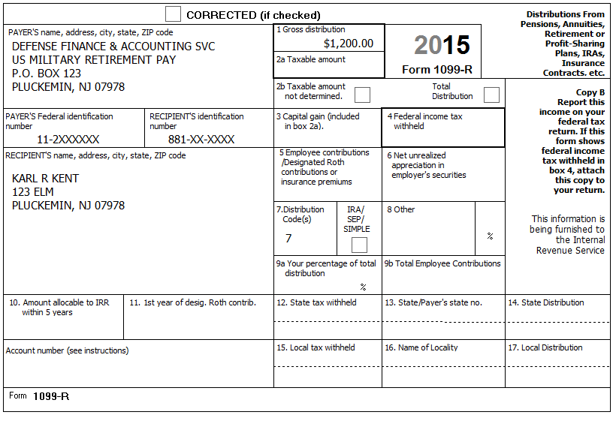
Reference: 4012 D-17 to D-24
Reference: NJ Special Handling p?
NJ: Add -1200 to the Adjustments to: Line 19a row of the NJ Checklist
Federal Refund: 2,427 NJ Refund Amount: 1,680
Step 15 1099-R
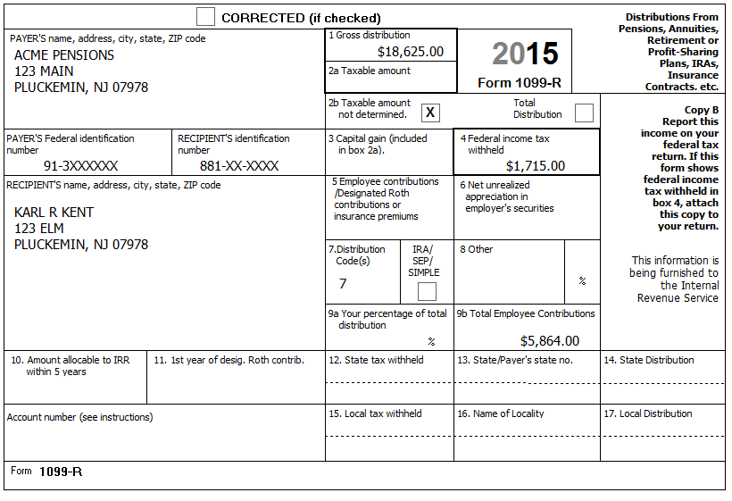
Karl retired two years ago, and started drawing his retirement pay from ACME Pensions on January 1, 2014. He recovered $335 of his cost during the first year. Karl did not select a joint and survivor annuity.
Reference: 4012 D-17 to D-24
Reference: NJ Special Handling p?
Tool: TSO built-in Simplified Method calculator
Tool: Annuity Calculator (link on Preparer page)
NJ: Record excluded amount on NJ Checklist – Adjustments to Line 19b
Federal Refund: 1,357 NJ Refund Amount: 1,674
Q: Why did the NJ Refund Amount change for this 1099-R, but not for the previous 1099-Rs?
Q: What, if anything, would change if this pension were for Kara instead of Karl?
Step 16 K-1
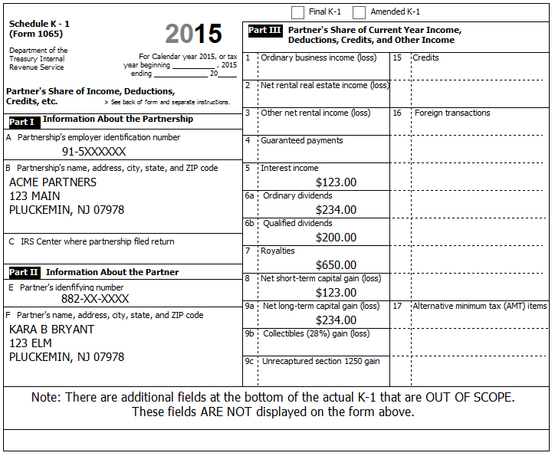
In addition to the above, Box 18a shows $321.00 of Tax Exempt Interest Income. This amount is all from Tax-exempt Federal obligations
You determine that a) This is a Passive Entity, b) All Investment is At-Risk, c) The entire investment has not been disposed, and d) This is not a PTP
Reference: 4012 D-53 to D-54
xTWO Hint: Direct entry on Schedule K (Other Income) Input form is ok in TSO. (and Sch E will be created automatically, if necessary)
Federal Refund: 1,184 NJ Refund Amount: 1,650
Step 17 1099-G (Unemployment)
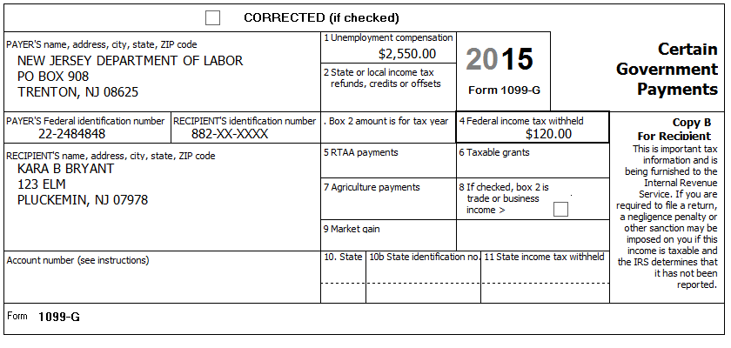
Kara said she received some unemployment, but didn’t receive any paperwork from the state. (NJ no longer sends out paper 1099-G forms for unemployment.) Luckily, Kara has her User ID and Password so you can help get a copy of her 1099-G online.
Tool: NJ Form 1099G Inquiry (Unemployment) (link on Preparer page)
Federal Refund: 922 NJ Refund Amount: 1,650
Step 18 SSA-1099
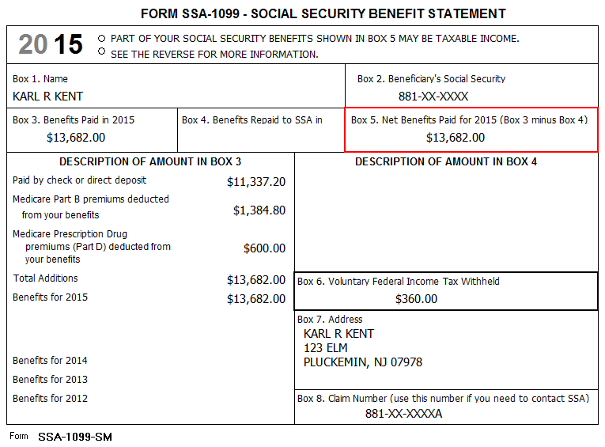
Reference: 4012 D-27
Q: Social Security is not taxed in NJ, so why did NJ Refund Amount change?
Federal Refund: (466) NJ Refund Amount: 1,667
Step 19a W2-G
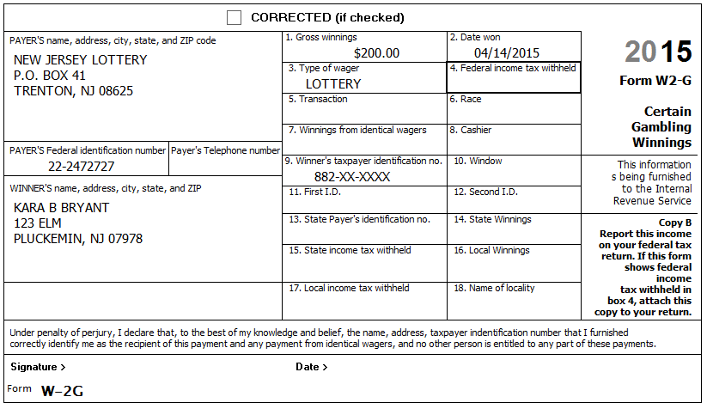
Reference: 4012 D-44
xTWO Hint: There is no place to enter Gambling Losses on the W2-G screen in TSO like there was in TWO – Gambling Losses are entered directly on one of the Sch A screens
NJ: Record on NJ Checklist (NJ Line 23 – Gambling Winnings)
Federal Refund: (496) NJ Refund Amount: 1,667
Step 19b W2-G
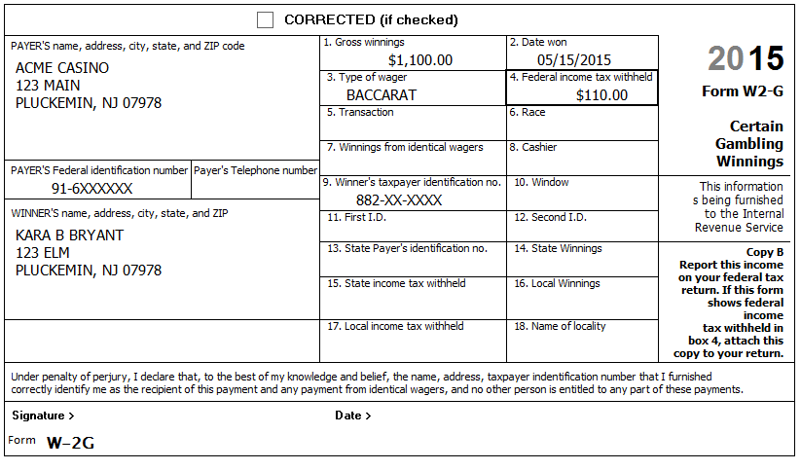
Reference: 4012 D-44
Hint: Gambling Losses will be entered in a later Step.
NJ: Record on NJ Checklist (NJ Line 23 – Gambling Winnings)
Federal Refund: (551) NJ Refund Amount: 1,667
Step 20 1099-C
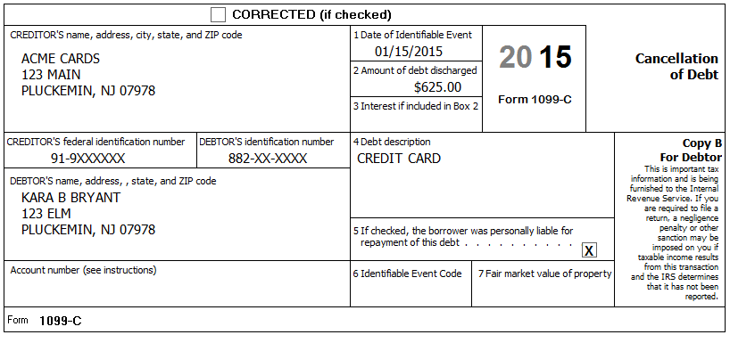
Kara was able to negotiate a deal with an overdue credit card to reduce her amount owed. The card was only used for personal expenses. She was solvent at the time and has never been involved in any bankruptcy proceedings.
Reference: 4012 D-48
Reference: NJ Special Handling p?
NJ: Record on NJ Checklist (Adjustments to: Line 25 – Other Income)
Federal Refund: (641) NJ Refund Amount: 1,655
Step 21 Notes – Educator Expenses
Kara bought her classroom supplies for her sixth graders and has receipts totaling $240.00. Kara worked over 1,000 hours and her costs were not reimbursed.
Reference: 4012 E-2
Federal Refund: (603) NJ Refund Amount: 1,655
Step 22 Notes – Alimony Paid
Karl paid $3,500 in alimony to a previous wife. The previous wife’s social security number is 886-XX-XXXX.
Reference: 4012 E-5
Federal Refund: (78) NJ Refund Amount: 1,716
Step 23 Notes – IRA Contributions
Kara contributed $3,000 to her traditional IRA account and another $3,000 to her Roth IRA account.
Reference: 4012 E-5
Hint: Taxpayer has a retirement plan
Hint: Spouse DOES NOT have a retirement plan
xTWO Hint: There does not seem to be an analog to the IRA Wkt for entering Roth contributions
Federal Refund: 372 NJ Refund Amount: 1,716
Step 24 Notes – Student Loan payments
Kara’s brother, Kaleb, paid $268 interest on a student loan Kara incurred to obtain her teaching degree.
Reference: 4012 E-6
Federal Refund: 409 NJ Refund Amount: 1,716

Step 25 Notes - Deductions
Check: Before beginning this step, Use Compare Deductions to check that Itemized Deductions = 2,697
Hint: Some items in the following sub-Steps may not be deductible or may have already been entered – be alert…
Annoyance: The Compare Deductions amount does not seem to update until you click Continue enough times to take you from Deductions to Other Taxes, then go back to Deductions. Keep this in mind if you want to Check the Itemized Deductions value after each sub-step.
Step 25a Notes – Deductions – Medical and Dental
Medicare $1,985
Section 125 Medical (from W-2) $1,200
Insurance policy from HealthCare.gov $3,600
Doctor bills $1,653
Prescription drugs $965
Hospital bills $3,200
Prescription eyeglasses for David $210
Wheelchair for Carmen $290
Medical mileage 103 miles per month (1,236 miles total)
Funeral expenses $5,600
Long Term Care insurance (Kara) (partially subsidized by employer) $4,000
Reference: 4012 F-3 to F-8
Hint: The appropriate deduction amount for Marketplace (HealthCare.gov) policies can only be calculated after form 8962 has been completed – we will do this later.
Check: After this step, Itemized Deductions = 9,073
Federal Refund: 409 NJ Refund Amount: 1,898
Step 25b Notes – Deductions – Taxes You Paid
Sales Tax on a new car $2,100
Real estate tax (Principal residence) $7,135
Real estate tax (Empty lot in Georgia) $245
Reference: 4012 F-3 to F-8
BP: You must click “Begin Sales Tax Worksheet” and enter State and Number of days (but not percents) even if you do not have any extra sales tax on cars, etc.
NJ: Record Real estate tax on NJ Checklist (Property Tax)
Check: After this step, Itemized Deductions = 16,833
Federal Refund: 859 NJ Refund Amount: 1,898
Q: Itemized Deductions went up by 7,760 – why?
Step 25c Notes – Deductions – Mortgage Interest
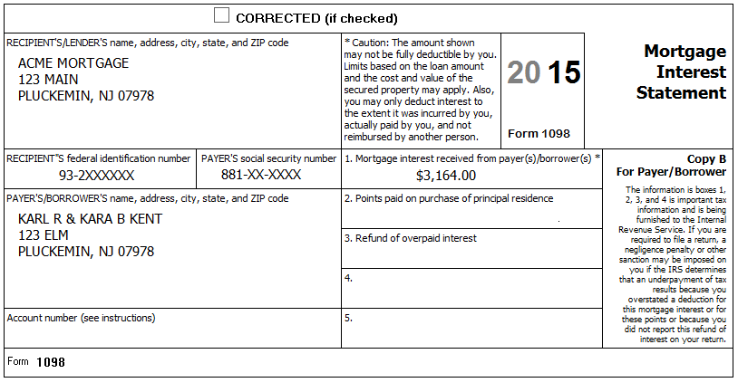
Reference: 4012 F-3 to F-8
Check: After this step, Itemized Deductions = 19,997
Federal Refund: 1,332 NJ Refund Amount: 1,898
Step 25d Notes – Deductions – Gifts to Charity
Church cash donations with canceled checks $1,650
Cash contributions to: National Public Radio, American Cancer Society,
Shriners Children’s Hospital with canceled checks and receipts $225
Contributions to Millsap Elementary School with canceled checks and receipts $250
Salvation Army (FMV of clothes and TV in good used condition;
Kents have receipts for these contributions.) $350
Donation to a political party $50
Reference: 4012 F-3 to F-8
Hint: If you use the Override option for Cash, then all you need to enter is the total (no names, dates, etc.) – Just be sure to document in the TP’s paper file how you arrived at the total.
Check: After this step, Itemized Deductions = 22,472
Federal Refund: 1,707 NJ Refund Amount: 1,898

Step 25e Notes – Deductions – Miscellaneous
Gambling losses (Lottery) $612
Gambling losses (Slots) $432
Speeding tickets $375
Reference: 4012 F-3 to F-8
BP: Be sure to not enter a number larger than actual gambling winnings – TSO does not check losses against winnings and will happily use whatever number you give it.
NJ: Record losses on NJ Checklist (NJ Line 23 – Gambling Winnings)
Check: After this step, Itemized Deductions = 23,516
Federal Refund: 1,857 NJ Refund Amount: 1,898
Step 26 Notes – Residential Energy Credit
The Kents insulated the crawl space of their home for $175.00 and replaced all their windows with new windows meeting the IECC criteria (energy efficiency) at a cost of $7,450.00 excluding onsite preparation, assembly, or original installation of components.
Looking at last year’s return, you see that the Kents had $305 of Nonbusiness energy property credit (Form 5695, line 30). They had no energy credits for years before last year.
Reference: 4012 G-10
Federal Refund: 2,052 NJ Refund Amount: 1,898
Step 27 Notes – Child and Dependent Care Expenses
Karl and Kara paid the Acme Day Care $1,100 to watch Dave while they worked. The address is 123 Main, Pluckemin, NJ 07978. The EIN for the center is 93-9XXXXXX. Acme Day Care is not a Tax Exempt organization.
Reference: 4012 G-3 to G-5
Federal Refund: 2,272 NJ Refund Amount: 1,898

Step 28 Federal Payments and Estimates
Karl and Kara applied $200 from last year’s federal tax toward this year’s federal taxes.
During the year, Karl and Kara made the following estimated tax payments:
Date | Federal
06-14 | $100
09-15 | $100

They would like vouchers for next year’s federal estimated payments ($120/quarter) generated as part of their printed return.
Reference: 4012 H-2 to H-3
Reference: NJ Special Handling p?
Federal Refund: 2,672 NJ Refund Amount: 1,898
Step 29 State Payments and Estimates
Karl and Kara applied $100 from last year’s state tax refund toward this year’s state taxes.
During the year, Karl and Kara made the following estimated tax payments:
Date | NJ
06-14 | $250
09-15 | $240

Reference: 4012 H-2 to H-3
Reference: NJ Special Handling p?
Federal Refund: 2,709 NJ Refund Amount: 2,488
Q: Why did Federal Refund go up?
Step 30 1098-T – Kendra
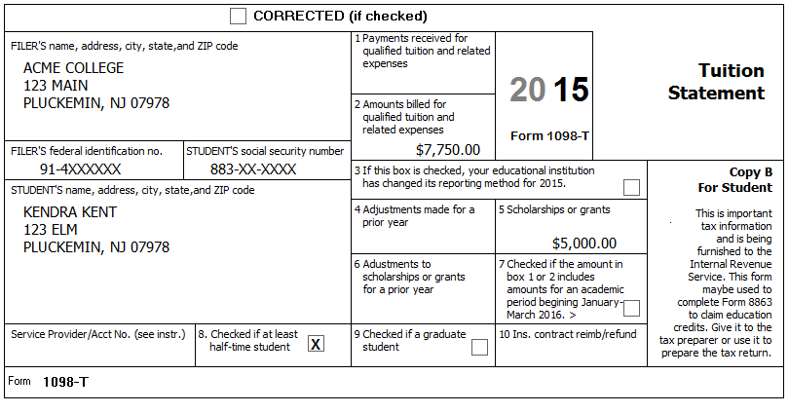
Kara and Karl paid $2,750 for Kendra’s college tuition plus an additional $3,500 for room and board. They spent $250.00 on textbooks and supplies (which were an enrollment requirement and paid to the college). They also spent another $400.00 on course related textbooks and supplies (which were not an enrollment requirement) plus $850.00 for a new computer (which was not a course requirement). Kendra did not receive a 1098-T for 2014. This is Kendra’s third year in her (undergraduate) college degree program. Kendra has no felony convictions of any kind.
Reference: 4012 Tab J
Hint: Be sure to pick correct Eligible Student
Check: Values for each option:
 | Qualified Expenses | Federal Refund
Tuition and Fees Deduction | 3,000 | 3,189
Lifetime Learning | 3,000 | 3,309
American Opportunity | 3,400 | 5,059

Federal Refund: 5,059 NJ Refund Amount: 2,488
Step 31 1098-T
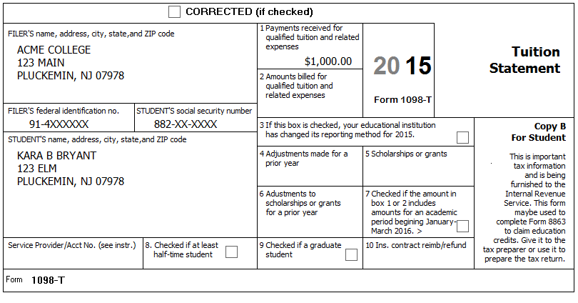
Kara had to take several courses that were required by her employer to advance her job skills. She spent $180 on course related books (which were not an enrollment requirement). Kara was not enrolled at least half-time.
Because the courses were not related to Kara’s self-employment, they cannot be a Sch. C business expense and we do not need to consider that option.
Reference: 4012 Tab J
Hint: Be sure to pick correct Eligible Student
Check: Values for each option:
 | Qualified Expenses | Federal Refund
Tuition and Fees Deduction | 1,000 | 5,217
Lifetime Learning | 1,000 | 5.259
American Opportunity | n/a | n/a

Q: Their tax bracket is 15%. Explain why the Tuition and Fees Deduction raises their Federal Refund by $158 instead of $150 (1,000 * 15%) – where did the extra amount come from?
Federal Refund: 5,259 NJ Refund Amount: 2,488

Step 32 IRS Identification PIN
Kendra received Notice CP01A from the IRS with an Identity Protection PIN - 142536
Reference: 4012 P-4
Federal Refund: 5,259 NJ Refund Amount: 2,488

Step 33 ACA Health Insurance
Karl and Carmen had Medicare all year.
Kara had no health insurance from January through March while she was unemployed. She had health insurance through her employer from April to December.
Kendra and Dave had insurance for January through June from a Marketplace policy. During July and August they had no health insurance. From September to December they were both covered through Kara’s employer.
None of the Kent’s dependents had a federal filing requirement.
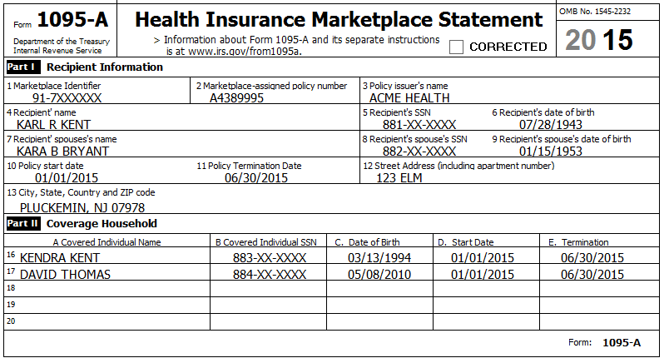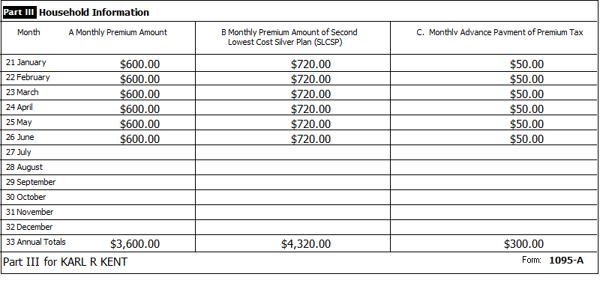
Reference: 4012 ACA Tab
Step 33a ACA Health Insurance – Health Insurance Section
Hint: Your local ACA expert says that Kara did not qualify for any exemption during the period from January through March while she was unemployed.
Federal Refund: 5,053 NJ Refund Amount: 2,488
Step 33b ACA Health Insurance – Add Sch A amount
Hint: To calculate the correct amount for Sch. A, you need to look at a couple of lines on the 1040 after completing the Health Insurance section in TSO. Use the following procedure:
- Calculate the “TY Net Premium” by subtracting the 1095-A, Column C total from the Column A total. (e.g. 3,600 – 300 = 3,300)
- Calculate the “Sch A Deduction Amount”:
  - If 1040, Line 46 (Excess advance premium tax credit repayment) has a value, add it to the “TY Net Premium”
  - If 1040, Line 69 (Net premium tax credit) has a value, subtract it from the “TY Net Premium”. (e.g. 3,300 – 90 = 3,210)
- Enter the “Sch A Deduction Amount” on the Medical Deductions screen in TSO.
BP: Be sure to document the calculation of the amount you end up entering into TSO for your Quality Reviewer and for the TP records.
Note: A previous version of this document said to use Line 24 from the 8962 to calculate the Sch A amount – This will not produce the correct result in all cases.
Federal Refund: 5,533 NJ Refund Amount: 2,544

State Section (New Jersey)
You have collected information during several Federal Steps on you NJ Checklist – It is now time to enter that information into TSO
Step 34 NJ Checklist – Basic Information
Enter New Jersey State Return – Basic Information
Annoyance: You need to click Continue until you get back to the original State Return screen before TSO will recalculate Refunds
Federal Refund: 5,533 NJ Refund Amount: 2,562
Step 35 NJ Checklist – Income Subject to Tax
Enter New Jersey State Return – Income Subject to Tax
Annoyance: You need to click Continue until you get back to the original State Return screen before TSO will recalculate Refunds
Federal Refund: 5,533 NJ Refund Amount: 2,578
Step 36 NJ Checklist – Subtractions from Income
Enter New Jersey State Return – Subtractions from Income
Annoyance: You need to click Continue until you get back to the original State Return screen before TSO will recalculate Refunds
Federal Refund: 5,533 NJ Refund Amount: 2,599
Step 37 NJ Checklist – Credits
Enter New Jersey State Return – Credits
According to the postcard from the tax office: – Block=50001, Lot-00002, Qualifier is blank.
Annoyance: You need to click Continue until you get back to the original State Return screen before TSO will recalculate Refunds
Federal Refund: 5,533 NJ Refund Amount: 2,714

Step 38 NJ Checklist – Tax
Enter New Jersey State Return – Tax
Based on the Estimated Use Tax Chart in the NJ-1040 Instructions, the Kents decide to pay $84 in Use Tax on their return.
Annoyance: You need to click Continue until you get back to the original State Return screen before TSO will recalculate Refunds
Federal Refund: 5,533 NJ Refund Amount: 2,630
Step 39 NJ Checklist – Miscellaneous Forms
Enter New Jersey State Return – Miscellaneous Forms
The Kents ask you to create NJ-1040-ES (Estimated Payment) vouchers for $20 per quarter.
Annoyance: You need to click Continue until you get back to the original State Return screen before TSO will recalculate Refunds
Federal Refund: 5,533 NJ Refund Amount: 2,630

e-File
Collect any final information necessary…
Step 40 E-File – Return Type
The Kents have a Federal refund which they want to Direct Deposit (per their Intake Sheet)
Hint: Federal Return Type = Direct Deposit
Step 41 E-File – Tax Preparation and E-File Information
The Kent’s email=KarlAndKara@mail.com
Step 42 E-File – State Return(s)
The Kents have a NJ refund which they want to Direct Deposit (per Interview)
Hint: NJ Return Type = Direct Deposit
Step 43 E-File – Taxpayer Bank Account Information
Step 44 E-File – Third Party Designee Info
Hint: Do NOT fill in anything here.
Step 45 E-File – Questions
Karl is a Veteran from the US Armed Force
Hint: Click Save when done
Step 46 E-File – Submission
BP: Click “Ready for Review” at the bottom of this screen

